Citibike Challenge

Overview

The purpose of this report is to identify key information to help identify key factors that should be considered while planning to implement a Citibike program in Des Moines, Iowa. This analysis is done by reviewing information from Citibike’s August 2019 Ridership data for New York City and providing insights to investors through Tableau’s Dashboard and Story tools.

Resources

Full Tableau Report (including all charts references in this file): <https://public.tableau.com/views/Citibike_Challenge_16321052452580/CitibikeChallenge-Story?:language=en-US&publish=yes&:display_count=n&:origin=viz_share_link>

GitHub Files (README and Python File):

<https://github.com/Roland791/bikesharing>

Results

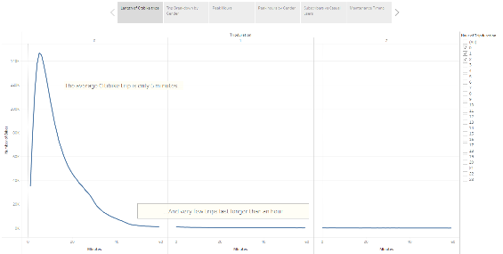

Figure - Length of Citibike Trips

When reviewing the trip length for Citibike users, it is evident that most trips only last around 5 minutes, and very few go beyond an hour. This would imply that most users are riding with a set destination in mind. Based on the additional graphs below, this would typically be to work or a central place of transit for commuters.

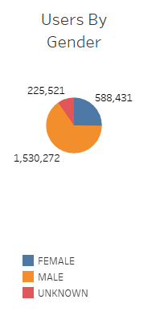

Figure - User breakdown by Gender

While the vast majority of users (over 2/3) are male, female ridership still accounts for almost a quarter of all users, with only a small percentage choosing not to self-identify. The skew would indicate that there is a untapped female market that might be worth investigating further.

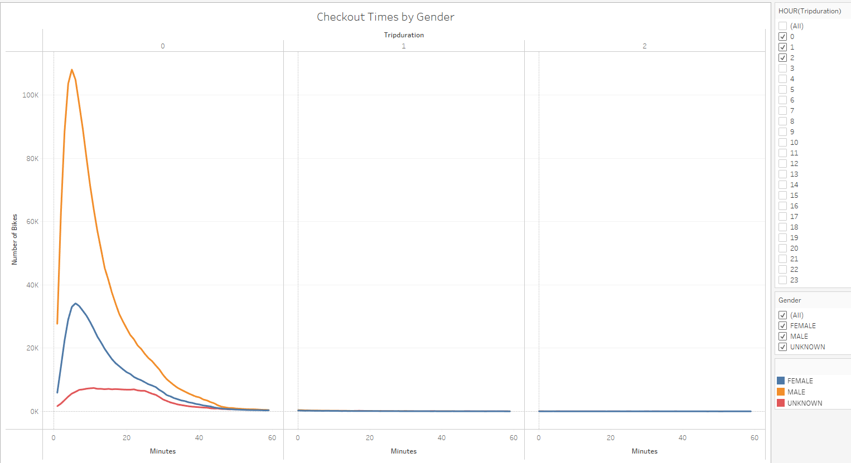

Figure - Trip Length by Gender

Interestingly, while men take make up the majority of users, there is no significant difference in the time that users spend based on their gender. Though, the flat rate of “unknown” users might indicate that these users may be more casual users, rather than dedicated commuters.

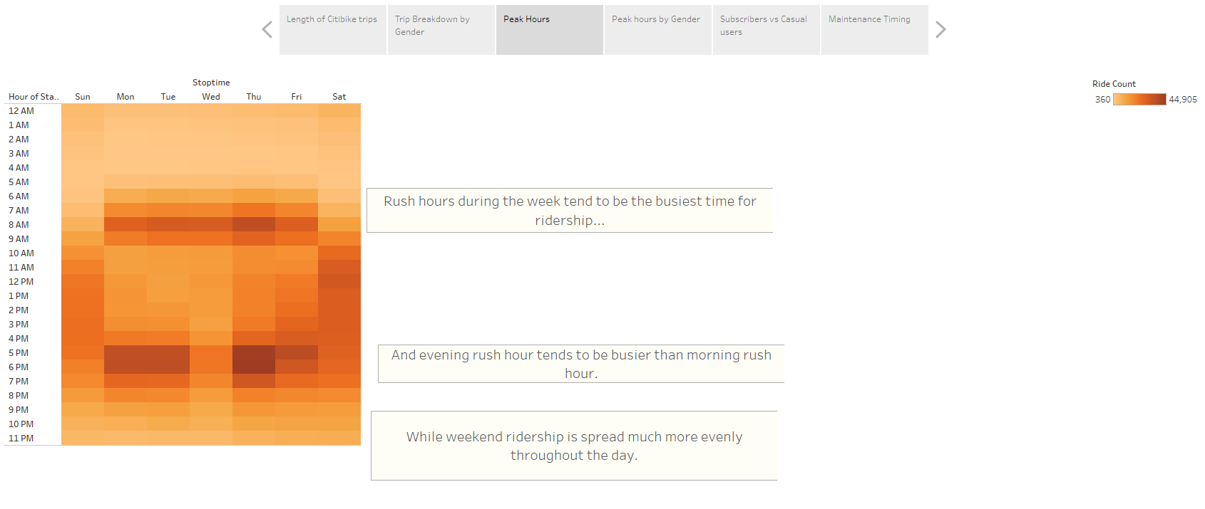

Figure - Peak Hours

Peak hours for users during the week sharply coincide with the rush hour timing for morning and evenings, though the evening hours are slightly higher, indicating some users may prefer to travel only during that time either because they aren’t in as much of a rush or they avoid the morning travel to reduce the potential for arriving at work sweatier than they would otherwise.

Interestingly, the peak hours on the weekend are spread more evenly throughout the day, probably because users are riding casually rather than with a set destination and time crunch. A deeper dive into this might yield some insights and potential selling points for weekend passes/rates geared towards casual users and tourists.

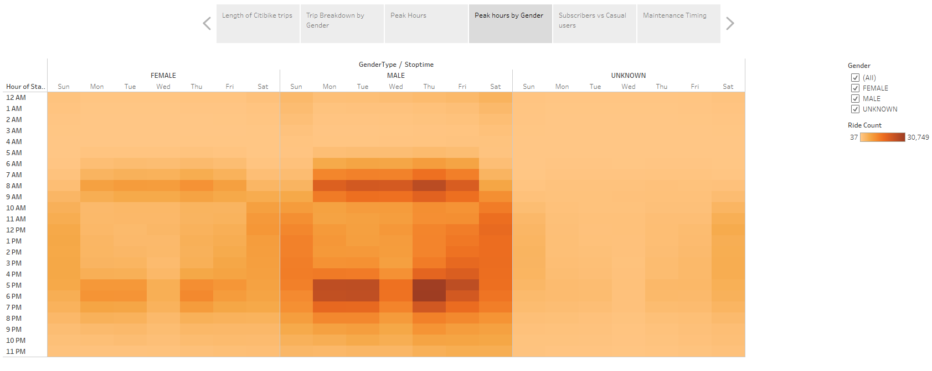

Figure - Peak Hours by Gender

As with the trip length, there doesn’t appear to be a major difference in the peak hours when broken down by gender. Overall, the highest rates are consistently during rush hour for both genders.

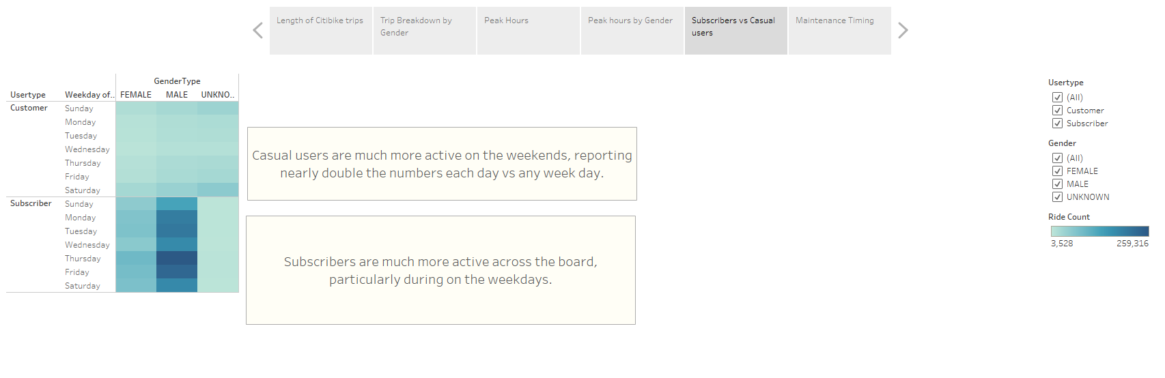

Figure - Subscribers vs Casual Riders

Overall, it is clear that subscribers are much more active users than casual riders. Additionally, Subscribers seem to be much more focused on the weekday rides, indicating they are commuters who are seeking to get the most out of their subscription. Casual riders tend to be heaviest on the weekend and could be tourists or families out to ride. As noted previously, this could create an opportunity for a weekend pass service aimed at these riders and increasing overall ridership on the weekends.

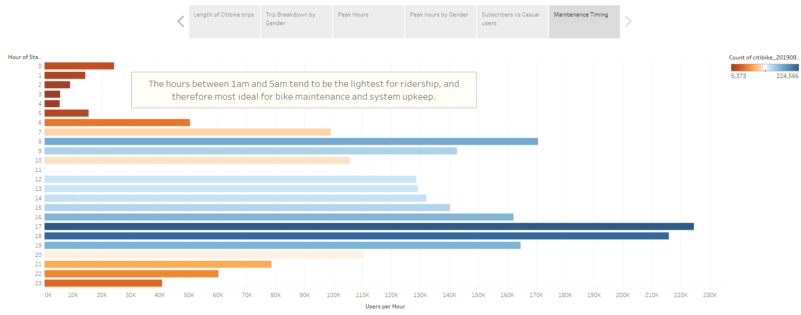

Figure - Maintenance Scheduling

Finally, based on the ridership by hours, it would logically make sense to aim maintenance services towards the early hours of the day (1am to 5am). This time shows the lowest usage and would provide the least amount of interruption for users.

Summary

Des Moines is ripe for Citibike. With a focus on subscriptions for weekday commuters and a marketing campaign geared towards the male demographic to start, we can also begin reviewing options for how to increase female and casual/weekend riders based on local data and the potential userbase. Two areas of additional analysis should be done by breaking down the average amount of time spent by users based on the day of the week, (weekends vs weekdays) and identifying the key commuting points within Des Moines to setup potential bike locations.